

# **1st Programming Assignment: Corner Detection**

CSE 6239 (July 2020)

Report By:

**Name**: Md Mamun Hasan

**Roll**: 1907555

**Description:**

Corner detection executed for 8 images with different criteria is reported below with results.

**Image**: img1.png

**Kernel**: Gaussian

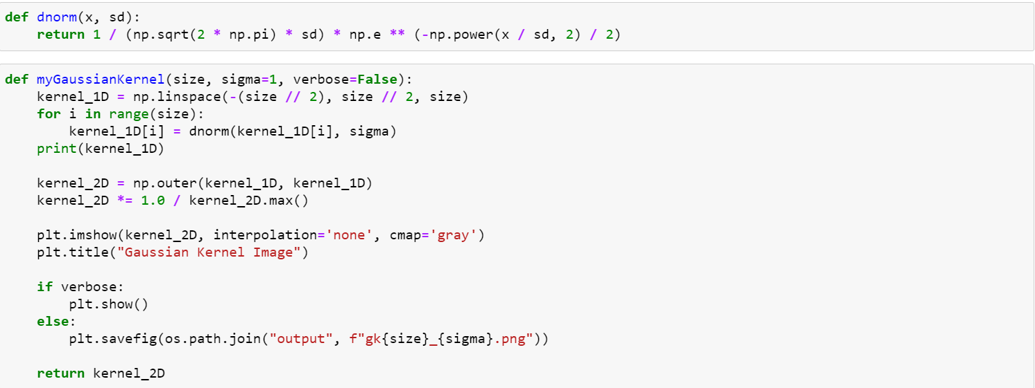

|  |  |  |  |  |
| --- | --- | --- | --- | --- |
|  | Size: 3  Sigma: 1 | Size: 5  Sigma: 2 | Size: 5  Sigma: 2  Scale: 0.75 | Size: 5  Sigma: 2  Scale: 1.25 |
| **Kernel** |  |  |  |  |
| **X Derivative** |  |  |  |  |
| **Y Derivative** |  |  |  |  |
| **Harris**  R Threshold = 10000.00 |  |  |  |  |
| **Kanade**  R Threshold = 100.00 |  |  |  |  |
| **Nobel**  R Threshold = 1.00 |  |  |  |  |

Bar chart for above **Gaussian** filter

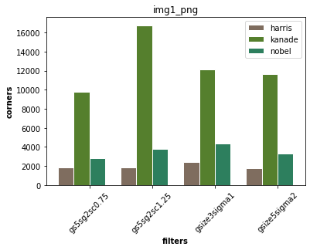

**Comments:**

1. Harris algorithm has worked well.
2. Kanade works very bad
3. Scale up detected more accurate corners
4. 15.5% corners are found common for 3 algorithms

**Kernel**: Box

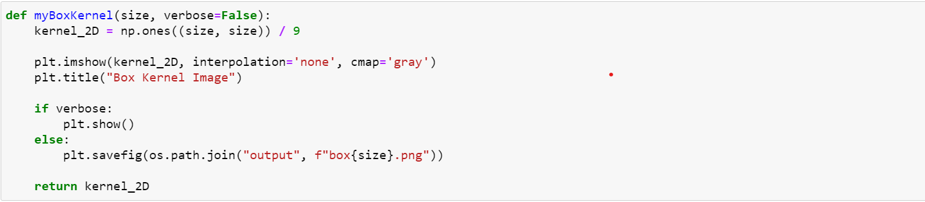

|  |  |  |  |
| --- | --- | --- | --- |
|  | Size: 3 | Size: 5 | Size: 5  Scale: 1.25 |
| **Kernel** |  |  |  |
| **X Derivative** |  |  |  |
| **Y Derivative** |  |  |  |
| **Harris** |  |  |  |
| **Kanade** |  |  |  |
| **Nobel** |  |  |  |

Bar chart for above **Gaussian + Box** filter

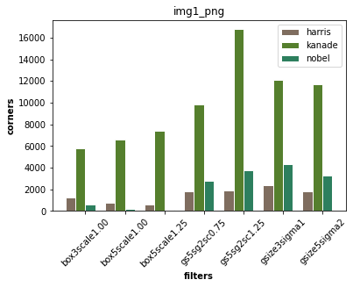

**Comments:**

1. Less corner detected in box filter
2. Again scaling up detect more corners

**Code from myImageFilter() conv by kernel:**

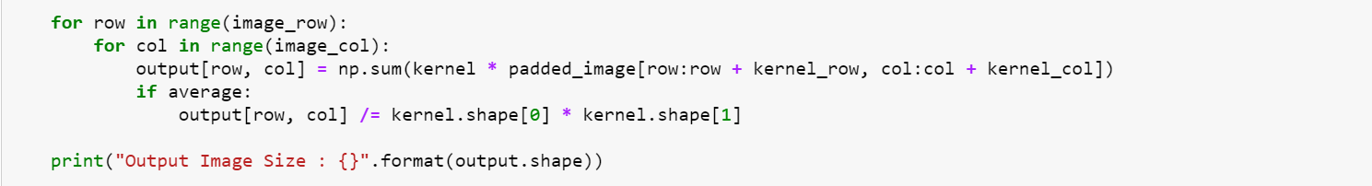

**Code for R calculation:**

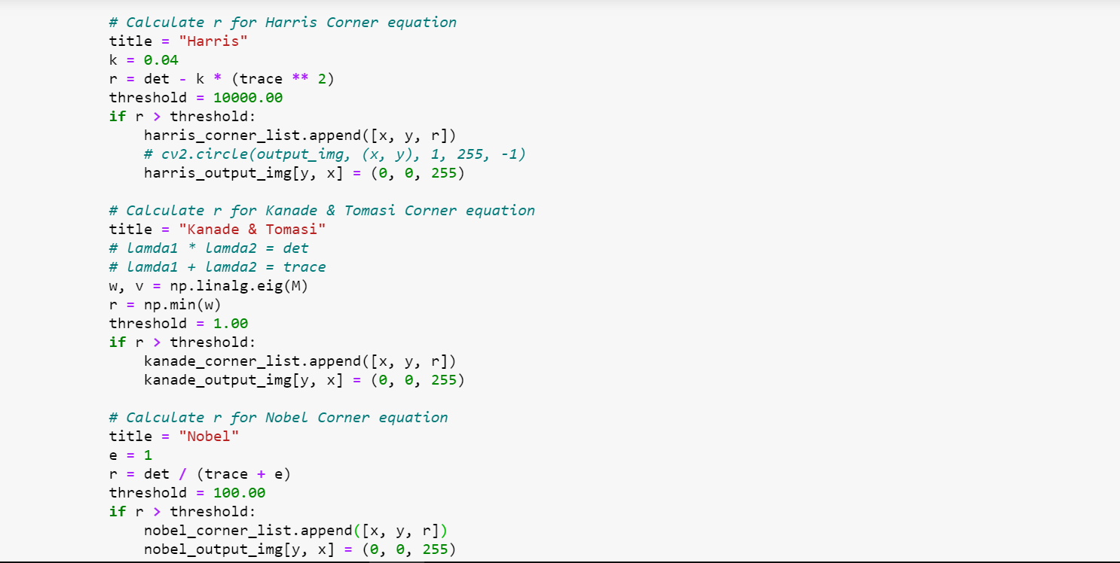

Similar process applied for all other provided images and For more programming reference please visit [here](https://github.com/mdmamunhasan/image-corner-detection/blob/main/corners.ipynb).